**Experiment-7 DT-10.11.2020**

**Aim**

To design synchronous and ripple(asynchronous) counters and test them.

**Apparatus required**

1) Tinkercad Software

2) Breadboard

3) Power Supply

4) Slideswitch

5) AND gate 74HC08

6) DUAL JK FF gate 74HC73

7) Resistors

8) LEDs

9) Connecting wires

**Theory**

Counter is a sequential circuit. A digital circuit which is used for a counting pulses is known counter. Counter is the widest application of flip-flops. It is a group of flip-flops with a clock signal applied. Counters are of two types.

* Asynchronous or ripple counters.
* Synchronous counters.

Asynchronous or ripple counters

The logic diagram of a 2-bit ripple up counter is shown in figure. The toggle (T) flip-flop are being used. But we can use the JK flip-flop also with J and K connected permanently to logic 1. External clock is applied to the clock input of flip-flop A and QA output is applied to the clock input of the next flip-flop i.e. FF-B.

Logical Diagram

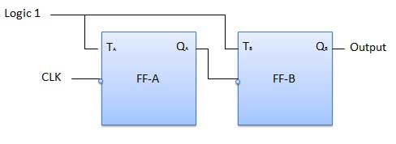

### Truth Table

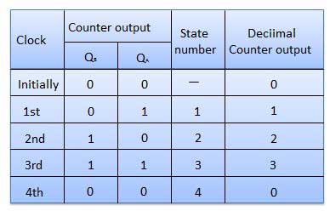

## Synchronous counters

If the "clock" pulses are applied to all the flip-flops in a counter simultaneously, then such a counter is called as synchronous counter.

### 2-bit Synchronous up counter

The JA and KA inputs of FF-A are tied to logic 1. So FF-A will work as a toggle flip-flop. The JB and KB inputs are connected to QA.

### Logical Diagram

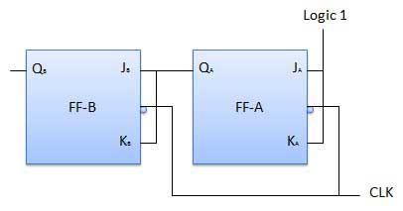

Classification of counters

Depending on the way in which the counting progresses, the synchronous or asynchronous counters are classified as follows −

* Up counters
* Down counters
* Up/Down counters

UP/DOWN Counter

Up counter and down counter is combined together to obtain an UP/DOWN counter. A mode control (M) input is also provided to select either up or down mode. A combinational circuit is required to be designed and used between each pair of flip-flop in order to achieve the up/down operation.

* Type of up/down counters
* UP/DOWN ripple counters
* UP/DOWN synchronous counter

UP/DOWN Ripple Counters

In the UP/DOWN ripple counter all the FFs operate in the toggle mode. So either T flip-flops or JK flip-flops are to be used. The LSB flip-flop receives clock directly. But the clock to every other FF is obtained from (Q = Q bar) output of the previous FF.

* **UP counting mode (M=0)** − The Q output of the preceding FF is connected to the clock of the next stage if up counting is to be achieved. For this mode, the mode select input M is at logic 0 (M=0).
* **DOWN counting mode (M=1)** − If M = 1, then the Q bar output of the preceding FF is connected to the next FF. This will operate the counter in the counting mode.

Example

3-bit binary up/down ripple counter.

* 3-bit − hence three FFs are required.
* UP/DOWN − So a mode control input is essential.
* For a ripple up counter, the Q output of preceding FF is connected to the clock input of the next one.
* For a ripple up counter, the Q output of preceding FF is connected to the clock input of the next one.
* For a ripple down counter, the Q bar output of preceding FF is connected to the clock input of the next one.
* Let the selection of Q and Q bar output of the preceding FF be controlled by the mode control input M such that, If M = 0, UP counting. So connect Q to CLK. If M = 1, DOWN counting. So connect Q bar to CLK.

Block Diagram

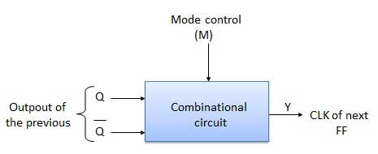

Truth Table

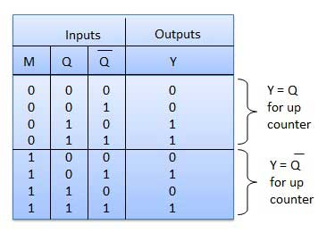

Modulus Counter (MOD-N Counter)

The 2-bit ripple counter is called as MOD-4 counter and 3-bit ripple counter is called as MOD-8 counter. So in general, an n-bit ripple counter is called as modulo-N counter. Where, MOD number = 2n.

Type of modulus

* 2-bit up or down (MOD-4)
* 3-bit up or down (MOD-8)
* 4-bit up or down (MOD-16)

Application of counters

* Frequency counters
* Digital clock
* Time measurement
* A to D converter
* Frequency divider circuits
* Digital triangular wave generator.

**Observation**:

Ripple up counter

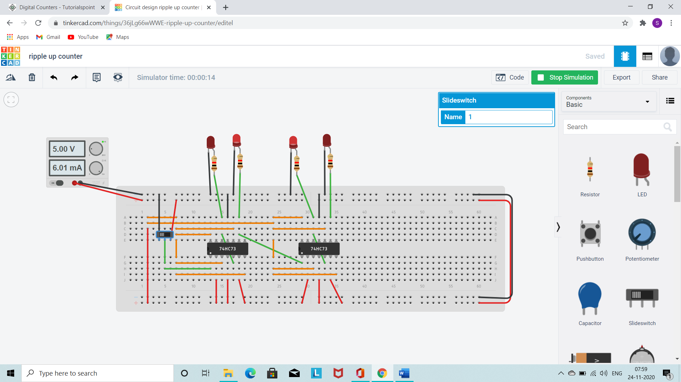

Ripple down counter

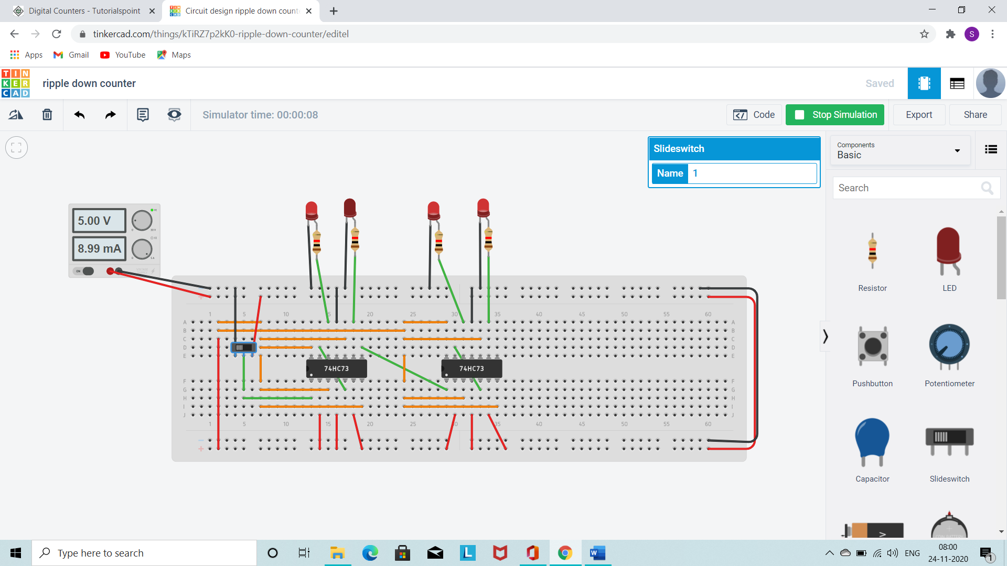

Synchronous up counter

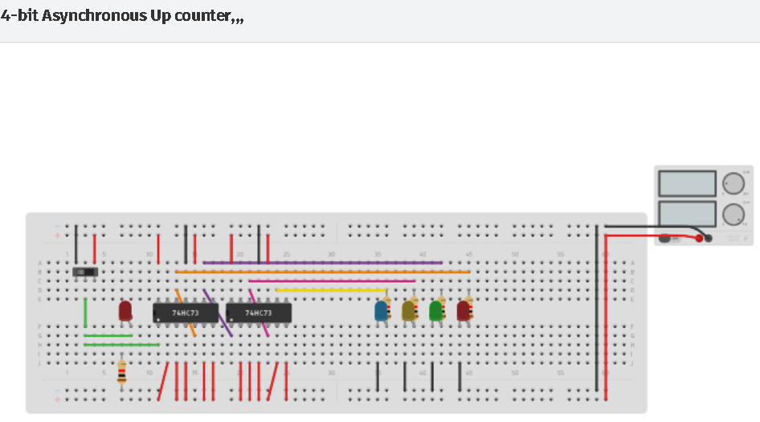

Synchronous down counter

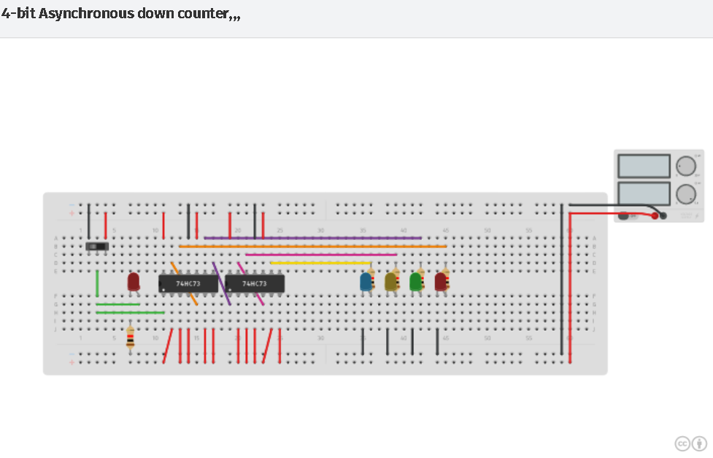

**Conclusion**:

All the circuits were designed and verified for all inputs.

**Name: Harsh Kumar**

**Branch: CE – 3 RD Sem.**

**ID- B219027**